21BIT0524

Software Engineering Lab DA-2

This document contains the UML diagrams of the Transcriptor and summarizer application



2024

Prashant .

PRASHANT

2/5/2024

TRANSCRIPTOR AND SUMMARIZER **SDS**

# Use case diagram

<<extend>>

Speak text

Audio to text

<<extend>>

 Summarize Text Copy text

<<extend>>

Save as text file Find meaning

<<include>>

User

Change app Theme Set file

location

Check speaker permission



Contact wordnet

For Meanings

System

Ask file location

# Class Diagram

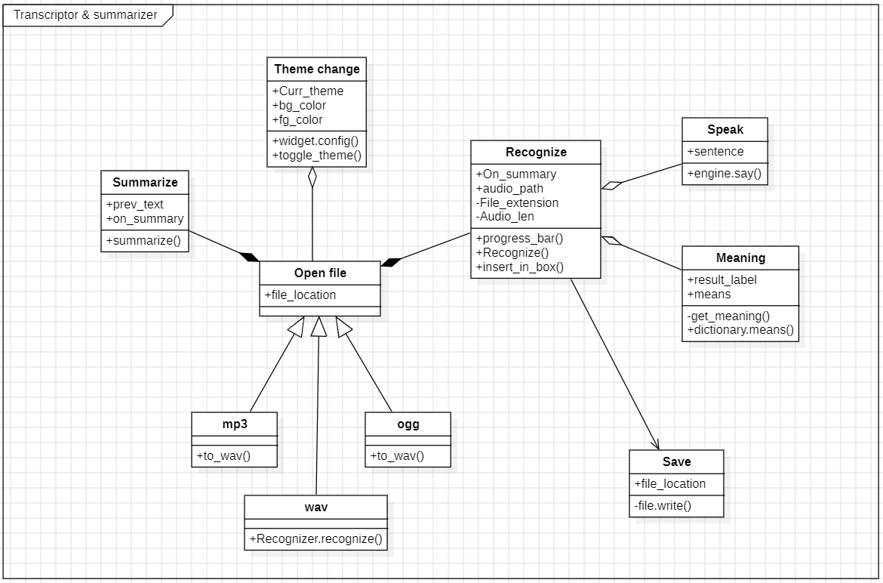

# Activity Diagram

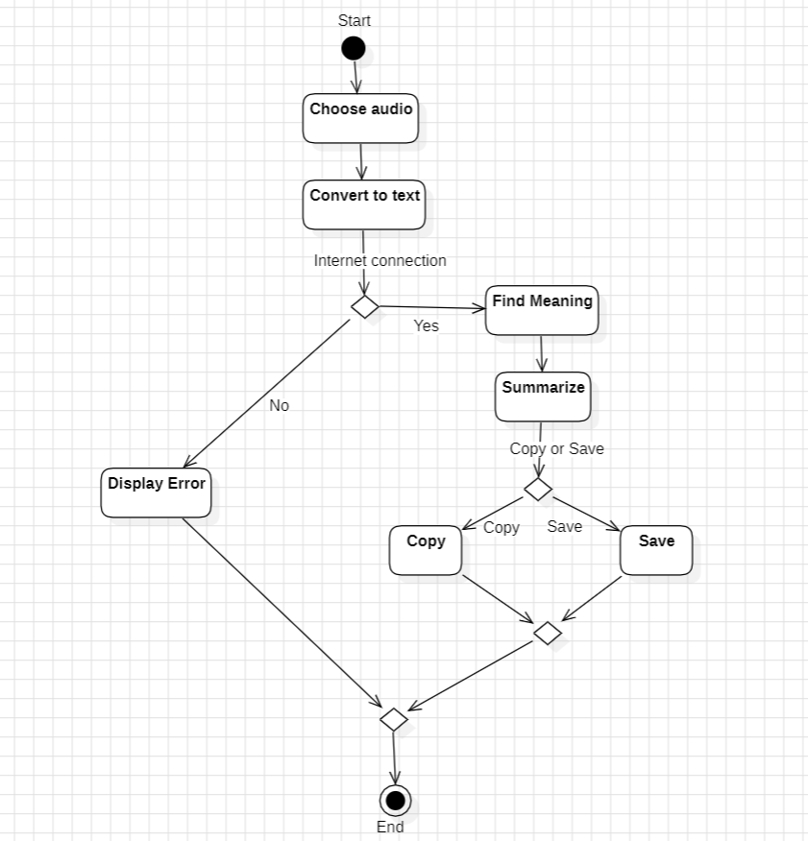

# Sequence Diagram

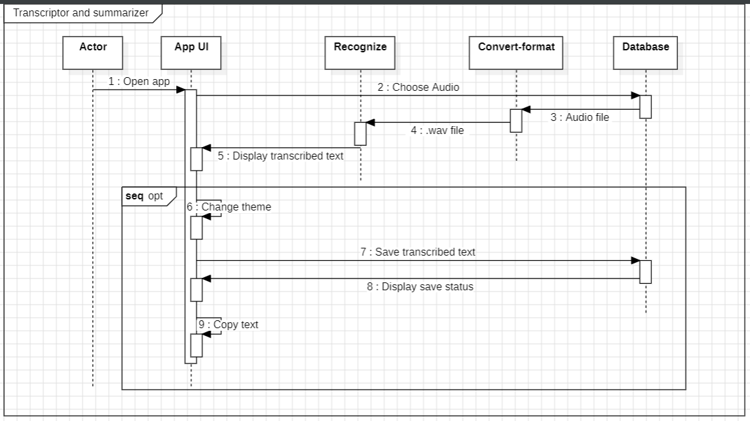

# Data Flow Diagram

